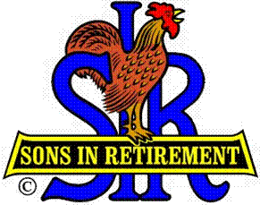

Las Trampas Branch 116

Executive Committee Meeting Agenda

January 15, 2018
9:30 AM
- Call Meeting to Order and confirm we have a quorum.
- Review Agenda/Minutes for Changes/Additions.
- Standing Reports:
Secretary – Fred Schafer – Approval of November 20, 2018 minutes
Attendance – Kevin Donahue
Head count, missed luncheon receipts
Membership – Phil Goff
New Members to be inducted:
Guests Today:
Visitors:

- Budget – Jim Nickels

- Big Sir Report:
- Welcome 2018
- No Storyteller: State of the Union, Marty Katz, Big SIR
- Chaplain: Dave Williams

- Little Sir Report:
- January Speaker: Monica Sanders – First Tee Organization
- Other

- Other Reports Phil Goff Form 27

- Adjourn – 10:15 am

